B”SD
BAINANY BIKE-A-THON
Bainany Group 5773

Boruch Hashem the Bainany
BIKE-A-THON was a real success!!! We raised over $400.00 for the kids of CHAI LIFELINE and had lots of fun doing it!!
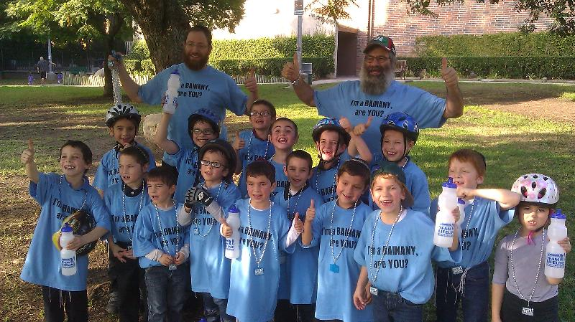

A big yasher koach to all the parents, bubbys and zaidys for your contribution and for your help! It’s very much appreciated.

Thanks again,
CHIEF BAINANY - Rabbi T

