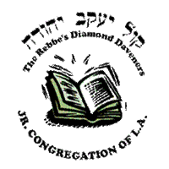
WHAT’S HAPPENING @ KYY?
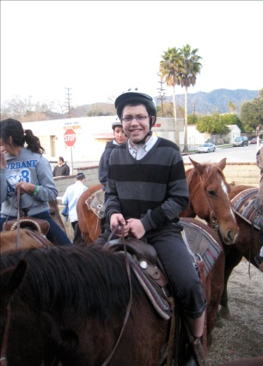
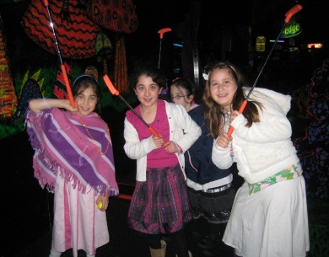
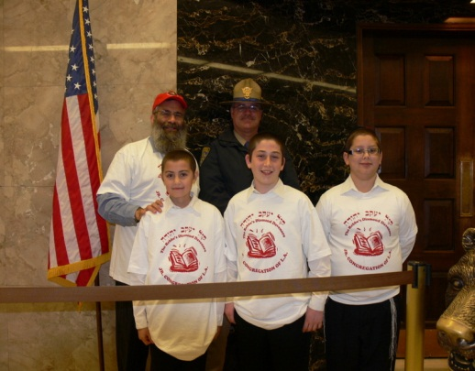
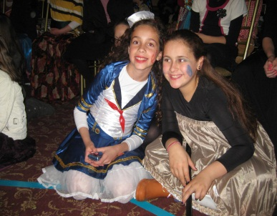
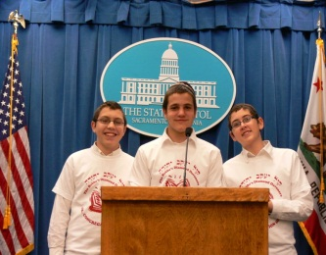
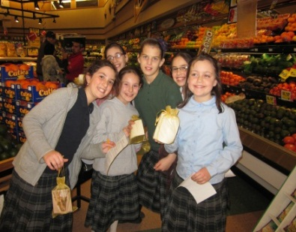
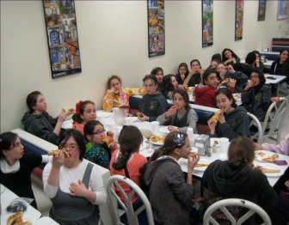
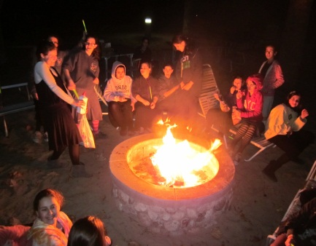
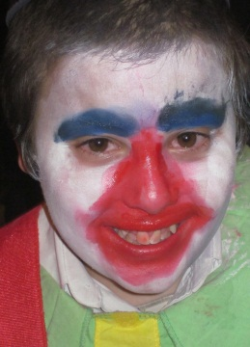
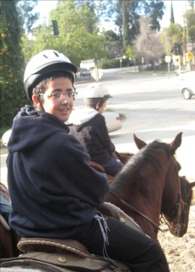
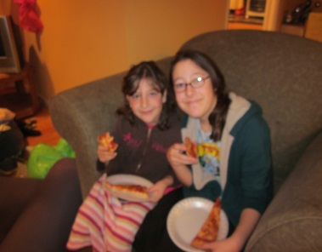
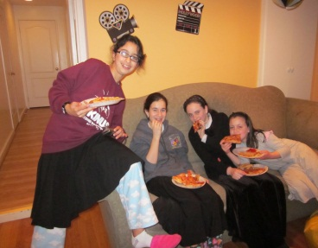
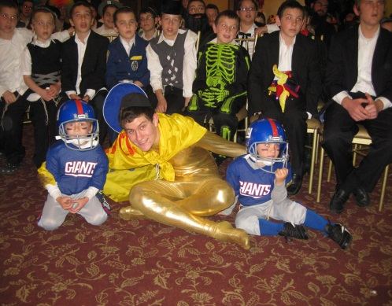
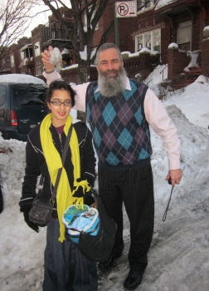
PRE PESACH UPDATE!

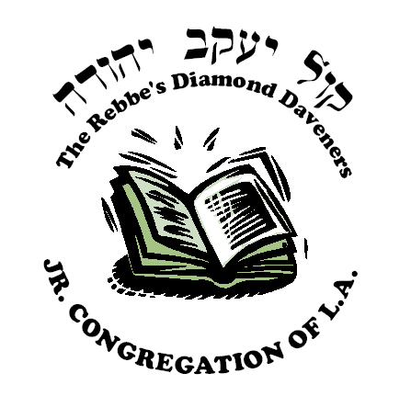
This year has been a roller coaster of fun… here’s a little overview of the exciting programs the children of KYY have had over the past few months!
Ezras Anoshim:

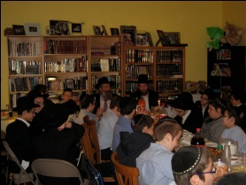
Yud Shvat Farbrengen

The room was full of the sound of boys singing niggunim,
as they farbrenged well into the night. Rabb Yitzchok Tene-
nbaum, gabai and Mashpia of Bais Menachem, told incredible e
stories that he heard from his Zaidy- Rabbi Leibel Groner, secretary of our Rebbe.
Shushan Horseback Riding
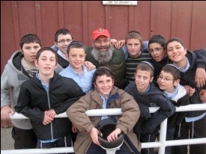
The horses galloped through the hills of Hollywood, taking
the boys back in time to the streets of Shushan Habirah.
Minch, Maariv, stories and skits made up for a great time!

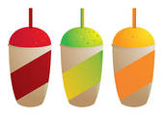
Slurpee Challenge Award

Our very own Officials presented a new challenge the past
few weeks – each week 3 best daveners are chosen!
Purim Extravaganza

Trick after trick, children and adults enjoyed a magical evening.
In costume and true KYY spirit, Purim Extravaganza #9 was the best yet!

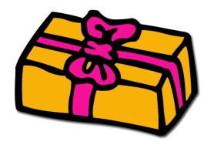
Prize Redemption Day

The moment we’ve all been waiting for all year!
The winners of the weekly KYY Kiddush raffles are finally able to come redeem their prizes! YAY!
Ezras Noshim
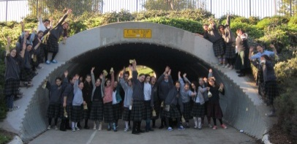
Irvine Shabbaton

Two words for this weekend – Chassidishe Fun!
Every second was filled with amazing activities, warmth
and excitement! From mivtzoyim, to late night pillow fights, to skits, to Shabbos walks, to niggunim, to the lagoon and even the car ride – every second was full of fun .
22 Shvat Zochel B’gorel Trip

The raffle was drawn Motzei Shabbos of the Shabbaton and Tzipora
Habibian was the Zoche B’gorel. She spent an entire weekend with the
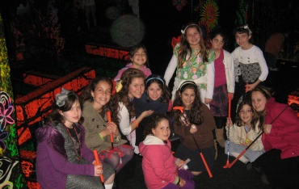
Shluchos at in inspiring and eventful Kinnus – a memory to last a life time!

In-town Shabbaton
3rd and 4th grade girls enjoyed an incredible day together
– from 9 in the morning until late on Motzei Shabbos. Activities, beautiful Shabbos meals, singing, hypnotists and glow-in-the dark miniature golf; it was a perfect day!
Late night under the Stars
Girls in the Ezras Nashim spent 8 weeks being on their best
behavior in order to earn an exciting late night!
Pizza + p.j.’s + popcorn+ games =PARTY.
Prize Redemption Day

The moment we’ve all been waiting for all year!
The winners of the weekly KYY Kiddush raffles are finally able to come redeem their prizes! YAY!

THINGS TO LOOK FORWARD TO…
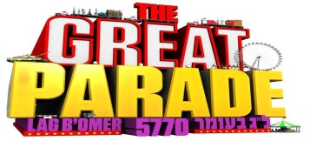
Lag Baomer Great Parade in
CROWN HEIGHTS & L.A.

Annual Shavuos Ice Cream Party!

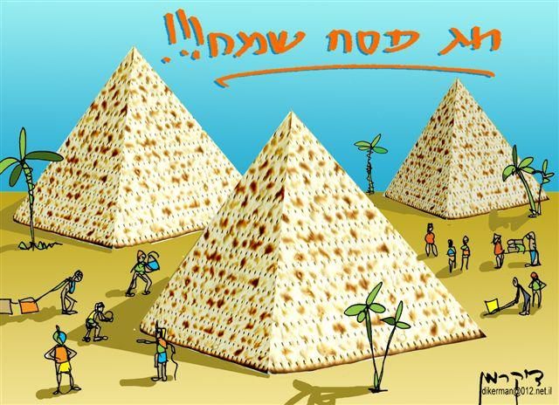

Wishing you a happy and freilichin Pesach!

Even more exciting programs coming up after Pesach…..
We're going to finish this year off great!

Your officials,
Efraim Schmukler – President
Efraim Lerner – Vice President
Levi Weiss – Secretary of State

